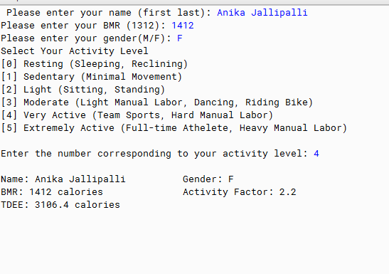

PMR: Relatively easy based on the last few lessons, the hardest part for me was the ability to give the choice of how much the exercised, I couldn’t find the lesson where they taught that!

/\*\*

\* Write a description of class TDEE here.

\*

\* @author Anika Jallipalli

\* @version 10/14/2019

\*/

import java.util.Scanner; //imports Scanner methods

public class TDEE

{

public static void main(String[] args)

{

Scanner in = new Scanner(System.in);

System.out.print("Please enter your name (first last): ");

String firstName = in.next();

String lastName = in.nextLine();

System.out.print("Please enter your BMR (1312): ");

int BMR = in.nextInt();

System.out.print("Please enter your gender(M/F): ");

String gender= in.next();

System.out.println("Select Your Activity Level");

System.out.println("[0] Resting (Sleeping, Reclining)");

System.out.println("[1] Sedentary (Minimal Movement)");

System.out.println("[2] Light (Sitting, Standing)");

System.out.println("[3] Moderate (Light Manual Labor, Dancing, Riding Bike)");

System.out.println("[4] Very Active (Team Sports, Hard Manual Labor)");

System.out.println("[5] Extremely Active (Full-time Athelete, Heavy Manual Labor)");

System.out.println();

System.out.print("Enter the number corresponding to your activity level: ");

String choice = in.next();

System.out.println();

//Processing:

// Activity Factor

double activityFactor;

boolean isMale = gender.equalsIgnoreCase("M");

@SuppressWarnings("unused")

boolean isFemale = gender.equalsIgnoreCase("F");

// Choice #0

if (choice.equalsIgnoreCase("0") && isMale) {

activityFactor = 1;

}

else {

activityFactor = 1;

}

// Choice #1

if (choice.equalsIgnoreCase("1") && isMale) {

activityFactor = 1.3;

}

else {

activityFactor = 1.3;

}

// Choice #2

if (choice.equalsIgnoreCase("2") && isMale) {

activityFactor = 1.6;

}

else {

activityFactor = 1.5;

}

// Choice #3

if (choice.equalsIgnoreCase("3") && isMale) {

activityFactor = 1.7;

}

else {

activityFactor = 1.6;

}

// Choice #4

if (choice.equalsIgnoreCase("4") && isMale) {

activityFactor = 2.1;

}

else {

activityFactor = 1.9;

}

// Choice #5

if (choice.equalsIgnoreCase("5") && isMale) {

activityFactor = 2.4;

}

else {

activityFactor = 2.2;

}

// Calculate TDEE

double tDEE = BMR \* activityFactor;

// Output: Print Results

System.out.println("Name: " + firstName+ lastName + "\t\tGender: " + gender);

System.out.println("BMR: " + BMR + " calories "+ "\t\tActivity Factor: " + activityFactor);

System.out.println("TDEE: " + tDEE + " calories ");

}

}